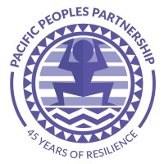
Executive Board Secretary
Volunteer, 2-Year Term

Pacific Peoples’ Partnership (PPP) elects an Executive Board Secretary to ensure the smooth operations of the Board. The Secretary ensures that board members are given appropriate notice of meetings and proactively records meetings. Duties will often extend beyond this to support where and as needed.
The Secretary of the Board will have the following duties and responsibilities:
- Maintains records of the Board and ensures effective management of the organization’s records.
- Manages the minutes of Board meetings.
- Ensure minutes are distributed to members in a timely manner after each meeting.
- Is sufficiently familiar with legal documents (articles, by-laws, etc.) to note applicability during meetings.
- Holds members accountable for their tasks.
The Executive Board Secretary has to be on top of every task, which also means that this individual needs a fluid set of skills. Some desirable qualities for this position include strong communication skills and the ability to organize and prioritize tasks. This extremely driven and detail-oriented leader should also be well-versed in administrative work.
The Secretary must be able to learn quickly and juggle many things. They will offer administrative support to the ED and Executive Board President when and as needed, to prepare board meeting and committee documents.

